The Nuclear Option

Josh Manchester
The University of Colorado at Colorado Springs
TCID 2090: Tech Writing & Presentation
Mrs. Cheryl Birkelo
December 17, 2022
The Nuclear Option
As climate change continues to turn for the worst, the world must weigh the available options for producing the energy that drives modern society. According to the Center for Biological Diversity (n.d.), in 2005, energy generation from fossil fuels amounted to 86 percent of the world’s current greenhouse gas emissions. It contributed nearly all (98 percent) of the carbon dioxide (CO₂) emissions that contribute to global warming (para. 1). With fossil fuels leading the way to humankind’s certain destruction, the world must reduce or replace energy generated from these fuels. The world has a few options today for generating non-carbon energy, from nuclear to renewables such as wind and solar. Out of these options, nuclear fission power is the best choice for generating non-carbon-emitting energy regarding cost, efficiency, and reliability.
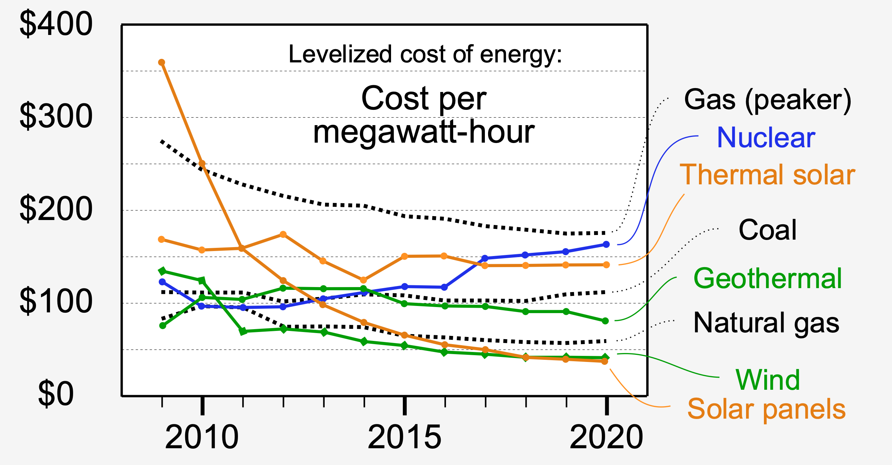
Many factors go into the cost of producing energy. It is expensive to build any power plant. According to Windustry (n.d.), a typical 2-megawatt (2MW) commercial wind turbine costs between $3-4 million when installed (para. 1 - 4). Jacob Marsh (2022), a Geoscience analyst, states that a comparable commercial 2MW solar farm would cost just over $2 million when installed (How much does a solar farm cost? section para. 1-2). As for nuclear, the U.S. Energy Information Administration (2022a) says the U.S. has nuclear plants that produce nearly 4000MW for $5.9 billion installed (para. 1-2). When scaled, a nuclear plant costs under $3 million for every 2MW produced. In the past, (1970’s) nuclear was almost as cheap as natural gas. Today nuclear power is becoming more expensive, but it is not because of the cost of nuclear itself. According to Michael Shellenberger (2018), a Time Magazine “Hero of the Environment,” Green Book Award Winner, and President of Environmental Progress, the cost of U.S. nuclear power is rising due to “renewables…receiving 94 times more in subsidies than nuclear and 46 times more than fossil fuels per unit of energy generated” (Renewables Revolution: Always Just Around the Corner section, para. 15). Environmental Progress. (n.d.) agrees and states that “if nuclear were subsidized at the same levels as solar and wind…nuclear would continue to be highly economical.” (Why is nuclear on the decline? section, para. 2). The effects of subsidizing can be seen through the Levelized cost of energy shown in Figure 1. Between 2009 and 2020, the cost of nuclear has gone up as the cost of renewables has gone down. It is not a matter of the actual cost of building and running the nuclear plant; it is how much the government is willing to spend to make it a viable option compared to other energy sources. Right now, public opinion about nuclear is driving governments to push for renewables even though nuclear is a clear choice.
Figure 1. Cost of energy. Curtesy Craig, R. (2022)
All power plants need capital investment, either from the government in the form of subsidies or from public investors. Capital investment for nuclear can be large compared to wind or solar because not only do nuclear power plants have to follow the normal health and safety regulations and laws like wind and solar power plants, but they also must follow laws from the International Atomic Energy Agency (IAEA). In his book Nuclear Law, Grossi, R. M. (2022) discusses the impact the laws set by the IAEA have on the use of nuclear materials. The IAEA follows four branches of nuclear law: safety, security, safeguards, and liability. Adhering to these laws adds cost to nuclear plant planning, construction, and operation because of the extra precautions that must be factored in when determining investment. Nuclear law is always changing to keep up as world events develop, such as COVID-19, the war in Ukraine, and civil unrest in countries like Iran (pages 2-5). This directly affects the cost per unit of energy for nuclear plants compared to renewables in sourcing fuel, security requirements, and storage of fissile material by-products to reduce proliferation. As already shown, even with these extra considerations for the initial capital and operating costs, a nuclear plant can still compete with renewables, especially when the government provides subsidies.
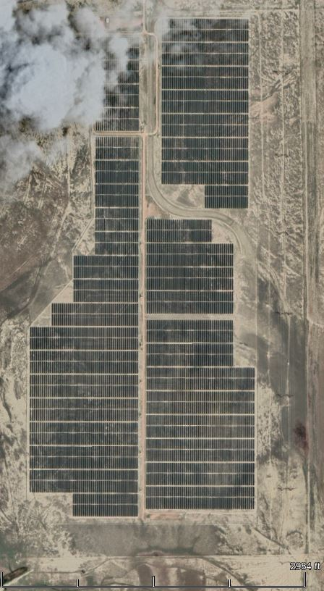
Land area is another key factor in the cost of generating energy. A wind farm takes up large amounts of land as each wind turbine needs to be spaced a long distance from other turbines so the blades can catch as much wind as possible. It is the same for solar, which can be seen in Figure 2. Look at any large commercial solar farm and see how much land is devoted to the photovoltaic cells (PVs). According to the Nuclear Energy Institute (2015), a nuclear power plant requires about 1.3 square miles of land per 1,000 megawatts produced. This number is based on the average land used by the 55 nuclear facilities in the U.S. Accordingly, a typical wind farm would need to produce between 1,900 megawatts and 2,800 MW to generate an equivalent amount of power in a year compared to a 1,000 MW nuclear energy facility. Such a farm would take up 260 to 360 square miles of land. A solar PV farm must produce 3,300 to 5,400 MW to be on equal ground with a 1,000 MW nuclear power plant and would need to be built on 45 to 75 square miles of land (para. 1-8). Hands down, nuclear is the best choice for land use unless buying up large amounts of land is no problem.
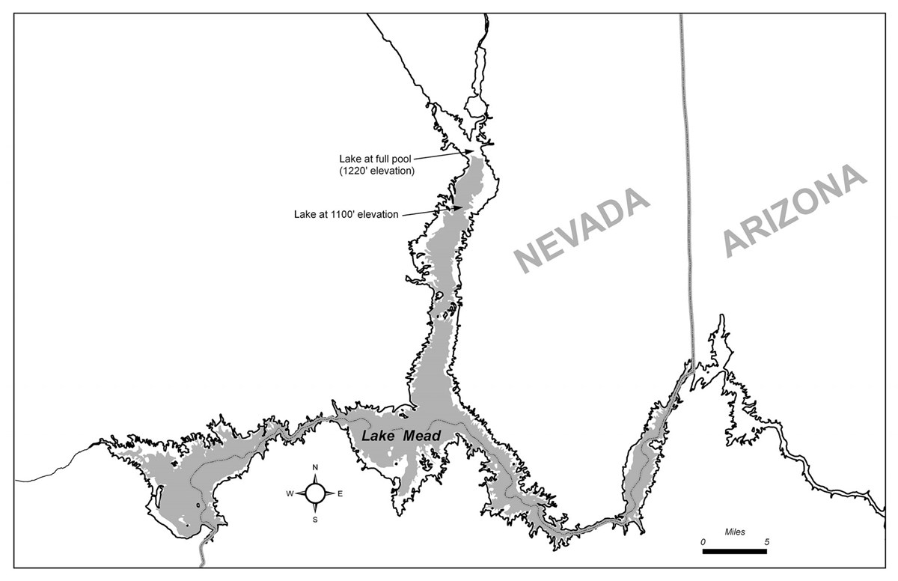
Figure 2. Solar farm, Colorado Springs, CO. Curtesy SpringsView (n.d.)

Hydroelectric power is another example of a power plant that takes up a large amount of land. But in this case, the power plant is not the problem; it is the fuel. As shown in Figure 3, Lake Mead, the largest man-made lake in the U.S., has a surface area of 637.05 square kilometers or about 255 square miles, putting it just under the typical land use for wind turbines. The water from this lake is used to turn turbines at the Hoover Dam producing power and water for most of the American Southwest. Most countries consider what will be lost when one of these lakes is filled, but some do not. These lakes can displace wildlife, sometimes endangered, and people as well. Encyclopedia Britannica (n.d.) states that the history of the Three Rivers Gorge dam is fraught with dubious decisions by the Chinese government. The dam’s construction saw 1.3 million people removed from over 1,500 towns and cities along the river and submerged numerous culturally significant structures beneath the lake's surface (History and controversy of the Three Gorges Dam Section, para. 1). In the U.S., the Hetch Hetchy Reservoir flooded a valley that was said to be almost as scenic as Yosemite. These power plants consume a lot of land area, and the lake that the power plant requires can damage the local ecosystems beyond repair.
Figure 3. Overview of Lake Mead, National Park Service (2020)
Land use can be even less if a Small Modular Reactor (SMR) is used. SMRs typically have a power output of about 10-300 MWs and, as their name implies, are small compared to current light and heavy water reactors. Reactors that produce less than 10 MW power are known as Microreactors, which have gained recent interest. The US Navy pioneered SMRs as we know them to be small and compact for use in nuclear submarines, and there was even an initiative to fit SMRs into planes as a means of near non-stop flight. Ingersoll & Carelli (2021) agree that SMRs are great because they are modular, meaning that a power plant can have one SMR or ten, the amount of power can be scaled to meet the needs of the area, and if more or less power is needed in the future, SMRs can be installed or removed to meet the change in need (pages 29-50). SMRs can also eliminate the need for long-haul power transmission via power lines. U.S. Energy Information Administration (2022b) states that the US power grid power losses from these long-haul lines equate to five percent of the grid's power loss from 2016 to 2020 (para. 1). Local power generation via SMRs can reduce or eliminate the need for long-haul power transmission. SMRs must be coupled with steam or other thermal power conversion units to produce power. Thermal conversion is where power is lost in this and other nuclear power plants, which reduces their efficiency.
Regarding efficiency, all power plants are flawed due to physics. All power plants must obey the laws of thermodynamics and therefore have losses in efficiency. Nuclear has a big loss in efficiency directly related to heat because heat is lost from the core as it boils water to steam to drive generators. But according to Energy Services Group International (2015), nuclear power plants can operate at 91 percent efficiency even with these losses (Nuclear Power Compared to Other Types of Energy section para. 1). Vourvoulias & Vishnubhotla (2022) state that solar is only 15 to 20 percent efficient on a cloudless day, depending on the angle of the sun and the latitude of the placement of the PVs. Still, the PVs lose even more efficiency when the PVs get hot, and energy is lost to heat from DC to AC inverters (Which Factors Determine the Efficiency of Solar Panels? section). The most efficient solar farms are normally built-in desert-type climates as these areas statistically get more sun, but a downside is how much sand can be blown against the PVs, causing wear on the panels and coating them with dust. As PVs get dirty, they lose efficiency requiring maintenance almost daily to keep the panels clean, which requires water. This means that these farms will compete with other industries in regions where water is already sparse. Also, as explained in the section on land use, solar power PVs need to be installed on large tracks of land to capture as much sunlight as possible to compensate for their low efficiency. The European Wind Energy Association (2016) reports that wind power is around 24 percent efficient. This is due to maintenance because of the large number of moving parts (turbines tend to break often), the amount of wind the turbine receives, how fast the wind blows, and the amount of land the turbines are distributed over (How efficient are wind turbines? section). Solar will be the go-to power source (if fusion power has not yet been perfected) in the future, but only when it becomes more efficient. According to the University of Tennessee Institute of Agriculture (n.d.), the amount of power from the sun that falls on the state of Texas (about one kilowatt per square meter) is 300 times more energy than all the power generated on earth. But until that day arrives, nuclear power is the most efficient power source available.
Even the most efficient power source is not 100 percent reliable. Reliability is measured by the fraction of time a power plant produces power compared to the time it is not. It can be observed that the sun only shines during the day and is most effective when the sky is cloudless. The same goes for wind; there are many days when the wind does not blow or does not have sufficient velocity (5 mph or greater) to push a wind turbine. The obvious answer to these shortcomings is to find areas of the country that are high in sun availability during the day (areas of the southwestern U.S.) or places with constant, high-velocity wind (high plains, central U.S.). As stated in the efficiency section, wind and solar need to produce substantially more to meet the same net output as nuclear. But unlike nuclear, wind and solar energy output is not reliable. A nuclear plant can vary power production as the daily need for energy fluctuates, but energy production from wind and solar is all or nothing. That much energy is not needed all the time, but when it is needed, such as at night (solar) or when the wind is stagnant, where will the energy come from?
The solution would be to store the extra energy that wind and solar make so they can be used when those sources become unavailable. Today, viable options for mass energy storage that can supply large cities with constant, high-efficiency, and reliable power exist but are decades away from large-scale deployment. Aleesha Rodriguez (2018), a Ph.D. student at the Queensland University of Technology, states that Tesla Motors and SpaceX entrepreneur Elon Musk had recently installed a battery system produced by Tesla in South Australia. The system has so far been successful in showing that this concept battery storage unit has promise. The problem with this system is that it was a one-off, was built in under 100 days over a bet, and used batteries meant for Tesla Motors cars, not a system to store and release large amounts of power (para. 1-6). Until energy storage systems like Elon’s become available and scalable, the overage of energy produced from wind and solar will be lost to us. But chemical battery systems are not the only way to store extra energy.
Hydroelectric power is an effective way to store the extra power generated from wind and solar, which could help put renewable energy generation on par with nuclear. This is known as a water battery, and when this water is used in a closed loop, the water stored in a lower and upper lake can be used to generate power when renewable energy sources wain due to the absence of the sun or wind. Using water in a closed loop means the water is not discharged into a stream or river that lets the water flow away from the dam. Instead, this water would be discharged from the power plant into a lower lake and, through electric pumps, transported to a higher lake for storage as potential energy. Water likes to evaporate, reducing the water in this closed system. Solar panels can be used as a sun shield over the tops of these lakes, reducing this evaporation by lowering or eliminating direct sunlight on the water. The solar panel coverings can reduce the external power needed to transport the water to the upper lake. Finding places to construct these water batteries’ hydropower plants is a major problem. These power plants need to be built in areas with a water source to prime the power plant’s lakes. These areas also need sufficient elevation changes between the upper and lower lakes to produce the water pressure needed to turn the plant’s turbines. This configuration can increase the reliability and efficiency of a hydroelectric power plant along with wind and solar. However, it still uses more land than nuclear and lacks the portability of nuclear.
Reliability for all power plants also rests on the availability of the fuel source. Wind and solar are clear winners here as both ultimately rely upon the sun as their energy source. Nuclear relies on sources of radioactive materials mined from the earth. Uranium is the primary source of fuel in most reactors today, but this resource can be hard to find, mine, and process to be usable. According to Nayak & Sehgal (2019), three to four times more thorium deposits on the earth can be accessed compared to uranium deposits, and thorium can be found in more countries worldwide. This means that more countries have direct access to this resource. Nayak & Sehgal further state that thorium can be directly substituted for uranium in most reactors that operate today, so no new reactors would need to be constructed to use thorium as a fuel. The authors also show that one of thorium’s biggest draws is that the by-product of a nuclear fuel cycle that uses thorium is the extremely low amount of fissile material produced that can be made into nuclear weapons, which gives it greater proliferation resistance (pages 27-37). The use of thorium as a fuel will greatly increase the safety and security of nuclear, but most important is the increase in reliability of nuclear.
Hydroelectric power can be as reliable as nuclear. With a large amount of stored water behind a dam, a hydropower plant can supply varied power as needs change throughout the day or year. What makes hydroelectric power unreliable is the fuel source. In this case, the fuel is water. The National Park Service (2020) keeps data on Lake Mead, the largest artificial lake in the U.S., and according to the NPS, Lake Mead’s volume is “3.5479 x 1010 meters cubed,” and a square surface area of “637.05 km”. That amount of water was thought to be enough in the 1930s when engineers designed it, and water-sharing rights were agreed upon by the states fed by the Colorado River basin (Lake Mead Characteristics section para. 1-2). But as we have found out, the current climate change in the region has all but shut off rain that feeds Lake Mead. Abdelsayed (2021) reported that the current drought striking the Southwestern U.S. has caused Lake Mead to shrink in size diminishing the water supplied to the Hoover Dam hydropower plant. Abdelsayed cites Patti Aaron with the Bureau of Reclamation, saying, “the Hoover Dam's hydropower efficiency has dropped about 25% due to the historically low levels [of water in Lake Mead]”. This means that most areas in the Southwestern U.S. that depend on Lake Mead will not only lose a needed source of power but also a desperately needed source of water. According to Abdelsayed, “the hydropower plant will continue generating power until Lake Mead's water level hits 950 feet”, a water level not seen in the lake since it was filled for the first time (para. 3-5, Minimum Water Level for Power para. 1). Ramirez (2022) confirmed in her report that power generation from the Hoover Dam power plant has fallen from “2,080 megawatts” down to “1,076 megawatts” as of June 2022. For the water-based power plant to operate efficiently, the water level behind the dam must be 1024 feet above mean sea level, or there will not be enough water pressure to turn the turbines for the power plant to achieve its best efficiency (para. 4-5). This is an inherent problem with all dam-supplied hydroelectric power plants worldwide.
In China, the Three Rivers Gorge dam and power plant were built to supply power and water to locals and calm floods on the Yangtze River. But, according to a report by Reuters (2022), due to unprecedented drought as of July 2022, the river had almost stopped flowing, causing lake Poyang’s water level behind the dam to fall drastically by 60 percent, endangering the livelihoods of the Chinese citizens relying on the Three Rivers Gorge dam for energy and water (para. 1-6). Dam-supplied hydroelectric power was considered a very reliable power source in the early to mid-twentieth century. Still, due to climate change, the reliability of hydropower is coming into question.
A reliable power source is right here, right now, and can be scaled to need. Nuclear power meets this need. Unlike solar or wind, a nuclear plant can be built just about anywhere, sized to the power requirements for the area undersupply, and produces power all the time, regardless of the conditions outside. Even when under maintenance, nuclear plants still produce power. Commercial power plants have multiple reactors. These additional reactors still produce power when one is offline for maintenance. Nuclear can operate without large energy storage units to supplement its power production when nature does not cooperate. Solar could be more reliable if diversified installation locations provide solar farms with a higher chance of sunlight. The same can be done for wind if installed in places where the wind is almost constant, increasing wind power’s reliability. As solar and wind power become cheaper to produce and power storage systems become readily available, these renewable energy sources will power the world. Large-scale deployment of countrywide viable and efficient renewable energy storage systems is still decades away, leaving one option for the near future, nuclear. But there is even better news on the horizon for nuclear. Generation IV power plants, which use liquid sodium instead of pressurized water for core cooling, have an extremely low probability of a core meltdown. The liquid sodium will stop the nuclear reaction if the core gets too hot instead of exploding like a Generation II plant that uses pressurized water as a coolant. Generation IV plants use spent fuel from past generations of nuclear plants. These plants are known as breeders as they make their fuel from the spent uranium of Generation II plants. With this kind of plant, the clear option for efficient power generation is nuclear, now and in the future.
Is nuclear even needed? According to Climate Nexus (2019), it may not be. Currently, the nuclear plants in the U.S. are aging and will need to be decommissioned, six have recently shut down, and nine more are slated to shut down shortly. These recent plant shutdowns have been replaced by natural gas plants, a significantly cleaner fuel source than coal, and some renewables. Still, there is fear that when future nuclear power plants shut down, the power plants that will replace them will use dirty fuels like coal and oil. The site references studies showing that all the power from existing nuclear plants could be replaced by renewables, such as the 2015 U.S. Deep Decarbonization Pathways study. The site also shows counter-studies advocating for the use of nuclear energy (Nuclear Capacity and the Power Grid section para. 1-2, Energy Pathways to Achieve Emissions Reductions Goals section para. 1-3, Nuclear Energy has Low Carbon Emissions but is Expensive and Risky section para. 1-3). Going without nuclear is indeed possible. Different values exist for different replacement levels, but complete replacement is possible. Still, it is estimated that converting 100 percent of the U.S. power grid to just solar would cost upwards of 24 trillion dollars in land, equipment (PVs and infrastructure), and installation costs alone. A comparison would be the U.S. GDP of 19 trillion a year. It would make more sense to bolster the existing nuclear plants and replace the aging coal/oil power plants with as much solar and wind as possible to go a slightly cheaper route. So, a full transition to renewables without the use of nuclear is possible, just extremely expensive.
With statistics, operating data, and a proven track record in nuclear’s favor, the public stigma that nuclear is inherently dangerous could kill our most efficient and reliable source of clean energy. With uneducated governments bending to the cry of the uneducated masses, nuclear will have an uphill battle. Germany is one example; after the Fukushima nuclear power plant meltdown on the east coast of Japan, the German government decommissioned its nuclear power plants and invested even more in solar power. According to Shellenberger’s (2017a) TED Talk, after Germany shut off its nuclear plants, the country’s greenhouse gas emissions started to increase because the amount of power that nuclear plants produced was in no way being replaced by the amount of solar that was installed. Germany is now a world leader in producing power from renewables, getting 46 percent of its energy from solar and wind. Germans also pay twice as much for their energy as French citizens do. France relies heavily on nuclear plants to produce its nation's power. Germany’s problem is that it supplemented the renewable energy power plants with natural gas plants, the cheapest fossil fuel source, trading a clean energy source for a dirty one. However, natural gas is not the dirtiest (that is coal); it is still considered dirty (entire video).
This stigma against nuclear power is rooted in its equiveillance with the proliferation of nuclear weapons or fissile materials that can be made into weapons. Shellenberger (2017b) elaborates on this public fear in his Jan 2017 TEDx Talk. Equating nuclear weapons with nuclear power was born out of propaganda from Californian naturalists/environmentalists who would do anything to demonize nuclear power. Eventually, they were able to get Hollywood behind them, and soon there was a Jane Fonda movie called “The China Syndrome” in which a nuclear power plant has an accident but does not melt down. That movie premiered one week before the accident at the Three Mile Island Nuclear Generating Station in Londonderry Township in Pennsylvania on March 28, 1979. Shortly after the accident, Fonda started a successful national campaign against nuclear power focused on mothers of young children, posing a question about whether nuclear power would poison their children (entire video). Have you ever heard the phrase “Save the Planet?” If so, consider what will happen to the planet if climate change continues. The answer is nothing; the planet will continue to orbit the sun just like it always has. The phrase should be “Save the Humans,” much like the 1980s slogan “Save the Whales,” because we are the ones in danger of going extinct. The fear should not be whether nuclear will harm our children but will our children be harmed if we do not embrace nuclear.
References
Abdelsayed, A. (2021). Lower water levels at Lake Mead mean less electricity from Hoover Dam. KTNV Las Vegas. Retrieved Sep 14, 2022, from https://www.ktnv.com/news/drought-crisis/lower-water-levels-at-lake-mead-mean-less-electricity-from-hoover-dam
Center for Biological Diversity. (n.d.). Energy and Global Warming. Center for Biological Diversity. Retrieved April 2019, from https://www.biologicaldiversity.org/programs/climate_law_institute/energy_and_global_warming/index.html
Climate Nexus. (2019). Nuclear Energy in the U.S.: Expensive Source Competing with Cheap Gas and Renewables. Climate Nexus. Retrieved Apr 2019, from https://climatenexus.org/climate-news-archive/nuclear-energy-us-expensive-source-competing-cheap-gas-renewables/
Craig, R. (2022). Levelized cost of electricity. wikipedia.org. Retrieved Nov 16, 2022, from https://en.wikipedia.org/wiki/Levelized_cost_of_electricity
Encyclopedia Britannica. (n.d.). Three Gorges Dam. https://www.britannica.com/. Retrieved Nov 16, 2022, from https://www.britannica.com/topic/Three-Gorges-Dam
Energy Services Group International. (2015). Know the Efficiency of Nuclear Power. Energy Services Group International. Retrieved April 2019, from https://www.esgi.net/2015/05/08/know-efficiency-of-nuclear-power-energy-staffing-jobs/
Environmental Progress. (n.d.). Technology, Innovation & Economics. Environmental Progress. Retrieved April 2019, from https://environmentalprogress.org/technology-innovation-economics/
European Wind Energy Association. (2016). Wind Energy's Frequently Asked Questions. European Wind Energy Association. Retrieved April 2019, from http://www.ewea.org/wind-energy-basics/faq/
Fu, R., Feldman, D., Margolis, R., Woodhouse, M., & Ardani, K. (Sep 11, 2017). U.S. Solar Photovoltaic System Cost Benchmark: Q1 2017. Paper presented at the https://www.osti.gov/servlets/purl/1390773
Grossi, R. M. (2022). Nuclear Law: The Global Debate - Chapter 1. (). T.M.C. Asser Press. 10.1007/978-94-6265-495-2_1
Ingersoll, D. T., & Carelli, M. D. (2021). Handbook of small modular nuclear reactors (Second edition ed.). Woodhead Publishing.
Marsh, J. (2022). Solar farms: what are they and how do they work? EnergySage. Retrieved Sep 14, 2022, from https://news.energysage.com/solar-farms-start-one/
National Park Service. (2020). Overview of Lake Mead. National Park Service. Retrieved Sep 14, 2022, from https://www.nps.gov/lake/learn/nature/overview-of-lake-mead.htm
Nayak, A. K., & Sehgal, B. R. (2019). Thorium; Energy for the future; Select papers from ThEC15. Springer.
Nuclear Energy Institute. (2015). Land Needs for Wind, Solar Dwarf Nuclear Plant’s Footprint. Nuclear Energy Institute. Retrieved April 2019, from https://www.nei.org/news/2015/land-needs-for-wind-solar-dwarf-nuclear-plants
Ramirez, R. (2022). The West’s historic drought is threatening hydropower at Hoover Dam. CNN. Retrieved Sep 14, 2022, from https://www.cnn.com/2022/08/16/us/hoover-dam-hydropower-drought-climate
Reuters. (2022). China's Yangtze river shrinks as heatwave, drought threaten crops. Reuters. Retrieved Sep 14, 2022, from https://www.reuters.com/world/china/chinas-yangtze-river-shrinks-heatwave-drought-threaten-crops-2022-08-15
Rodriguez, A. (2018). Remember the Giant Tesla Battery in Australia? It Just Marked Its First Year. ScienceAlert. Retrieved Apr 2019, from https://www.sciencealert.com/remember-the-giant-tesla-battery-in-australia-it-just-marked-its-first-year
Shellenberger, M. (2017a). How Fear of Nuclear Ends. Youtube. Retrieved April 2019, from https://www.youtube.com/watch?v=mI6IzPCmIW8&ab_channel=TEDxTalks
Shellenberger, M. (2017b). Why I changed my mind about nuclear power. Youtube. Retrieved Apr 2019, from https://www.youtube.com/watch?v=ciStnd9Y2ak
Shellenberger, M. (2018). We Don't Need Solar and Wind to Save The Climate -- And It's A Good Thing, Too. Forbes. Retrieved April 2019, from https://www.forbes.com/sites/michaelshellenberger/2018/05/08/we-dont-need-solar-and-wind-to-save-the-climate-and-its-a-good-thing-too/?sh=67c975eee4de
SrpingsView. (n.d.). SpringsView Geographic information system. https://gis.coloradosprings.gov/. Retrieved Nov 14, 2022, from https://gis.coloradosprings.gov/
U.S. Energy Information Administration. (2022a). How Much Electricity Does A Nuclear Power Plant Generate? U.S. Energy Information Administration. Retrieved April 2019, from https://www.eia.gov/tools/faqs/faq.php?id=104&t=3
U.S. Energy Information Administration. (2022b). How much electricity is lost in electricity transmission and distribution in the United States? U.S. Energy Information Administration. Retrieved Sep 14, 2022, from https://www.eia.gov/tools/faqs/faq.php?id=105&t=3
University of Tennessee Institute of Agriculture. (n.d.). The Sun's Energy. University of Tennessee Institute of Agriculture. Retrieved April 2019, from https://ag.tennessee.edu/solar/Pages/What%20Is%20Solar%20Energy/Sun's%20Energy.aspx
Vourvoulias, A., & Vishnubhotla, V. (2022). How Efficient Are Solar Panels? Green Match. Retrieved April 2019, from https://www.greenmatch.co.uk/blog/2014/11/how-efficient-are-solar-panels

Windustry. (n.d.). How Much Do Wind Turbines Cost? Windustry. Retrieved Apr 2019, from https://www.windustry.org/how_much_do_wind_turbines_cost

